**Wireframes- Order Promise and Need Identification**

**The main page of Order Promise and Need Identification looks like:**

**Here, the pre-populated data is the combination which is most frequently placed order by an agent. He has a flexibility to select other ship to party, payer, payment method, payment term, material as per his choice. Based on that, he can select allocation tile over which dispatch date, Allocated qty and input qty are visible.**

**Then there is a fetch icon against requested qty which has a property of showing allocation on the best effort basis.**

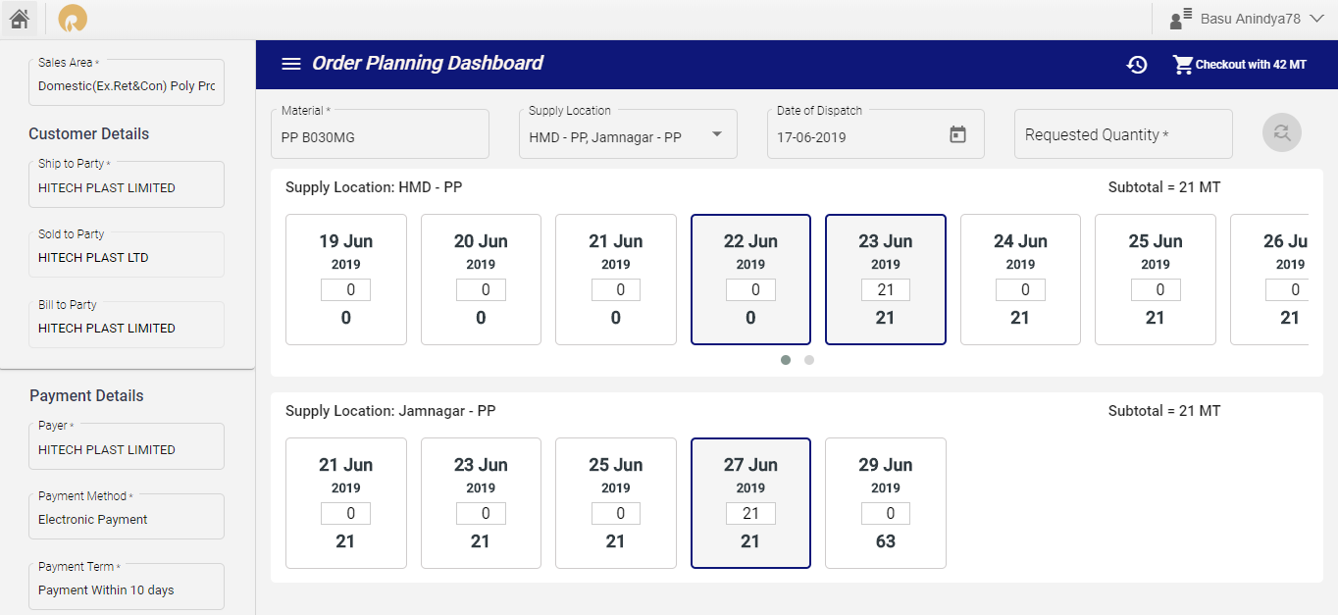

**Step 5: Agent selects the tile of allocation and then checkout to place order. This is the Order Summary page where he can cross check the value selected while placing the order.**

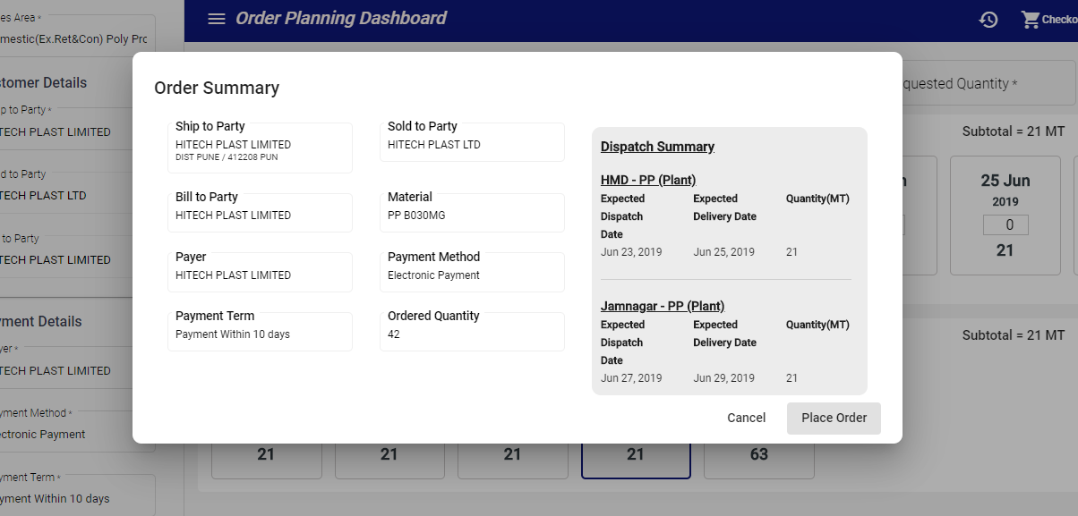

**Step 6: After placing order, It will generate the unique ref no.**

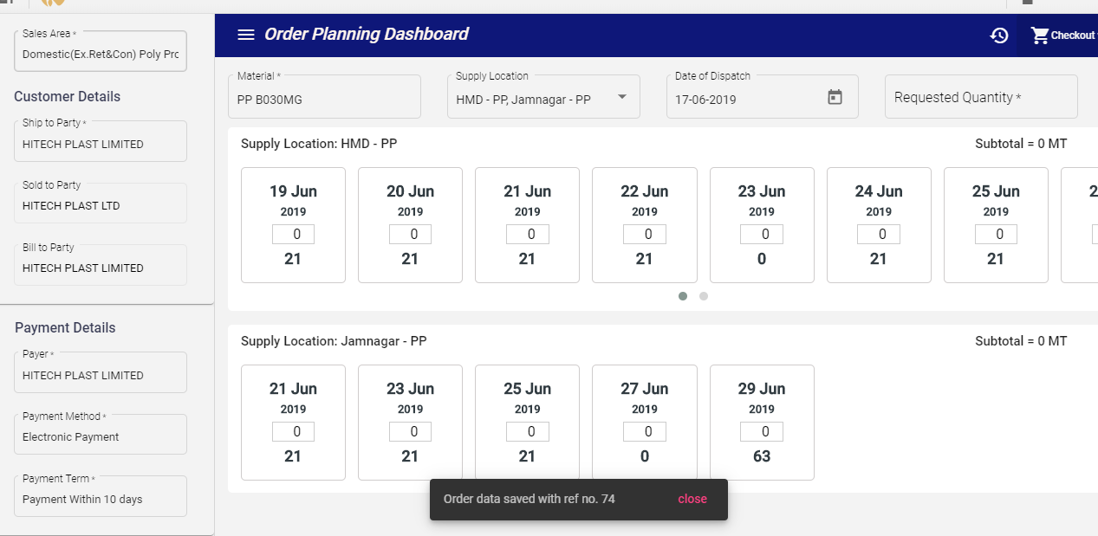

**Specific Functionalities:**

**Step 1: Zero Allocation:** It helps the agent to place an order for the combination containing customer details, payment details and material plant having no allocation found in the current month. It creates the allocation tiles from current date to end of the current month and allows him to place the order as per the selected quantities.

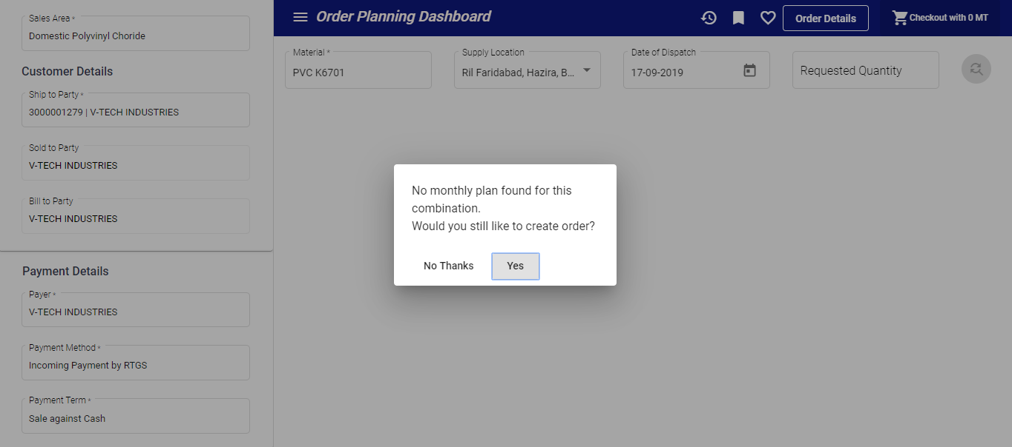

**Step 2: Split Allocation:** It will provide flexibility to user to get the allocation of dispatch date lies in next month in the current month itself. It will consolidate the next month of allocation with last day of the month in screen and let user know as per the expected dispatch date on the summary screen

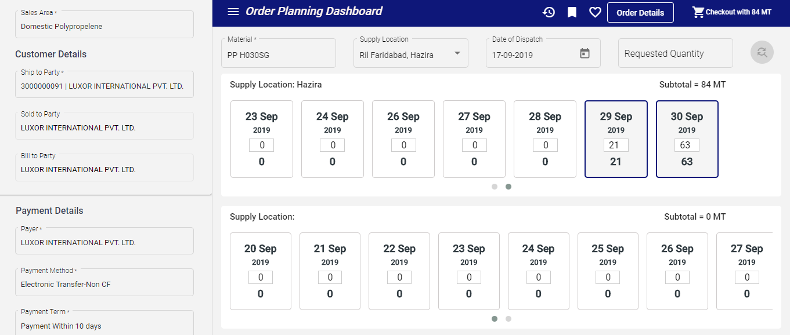

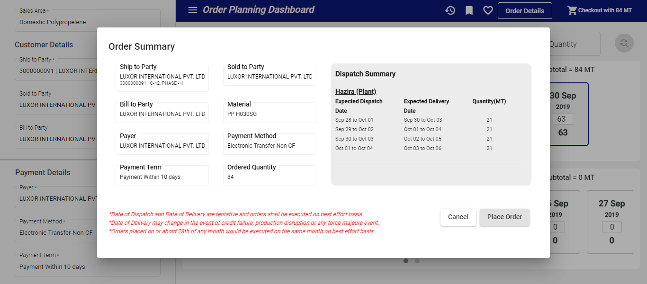

**Step 3: Favorite Addition:** It will help agent to create its favorite with a unique name based on the combination of customer details, material and payment details. It has a restricted criteria like favorite creation for same favorite name and same combination are strictly prohibited.

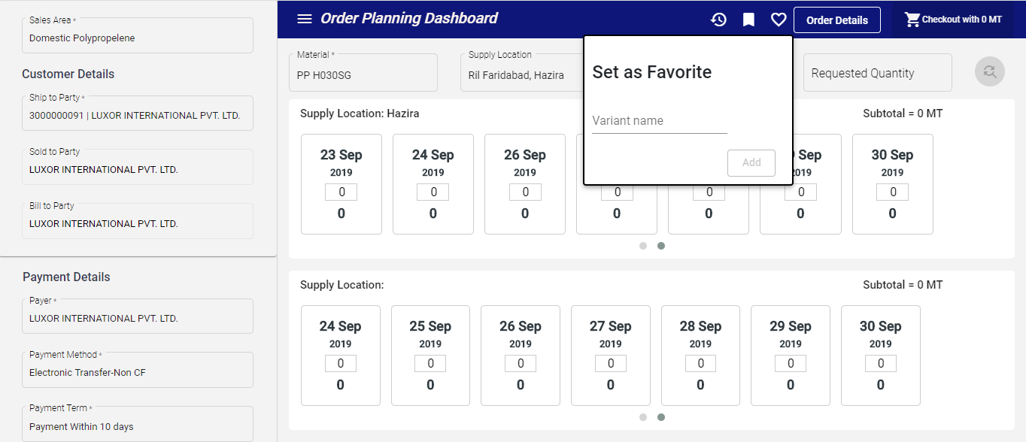

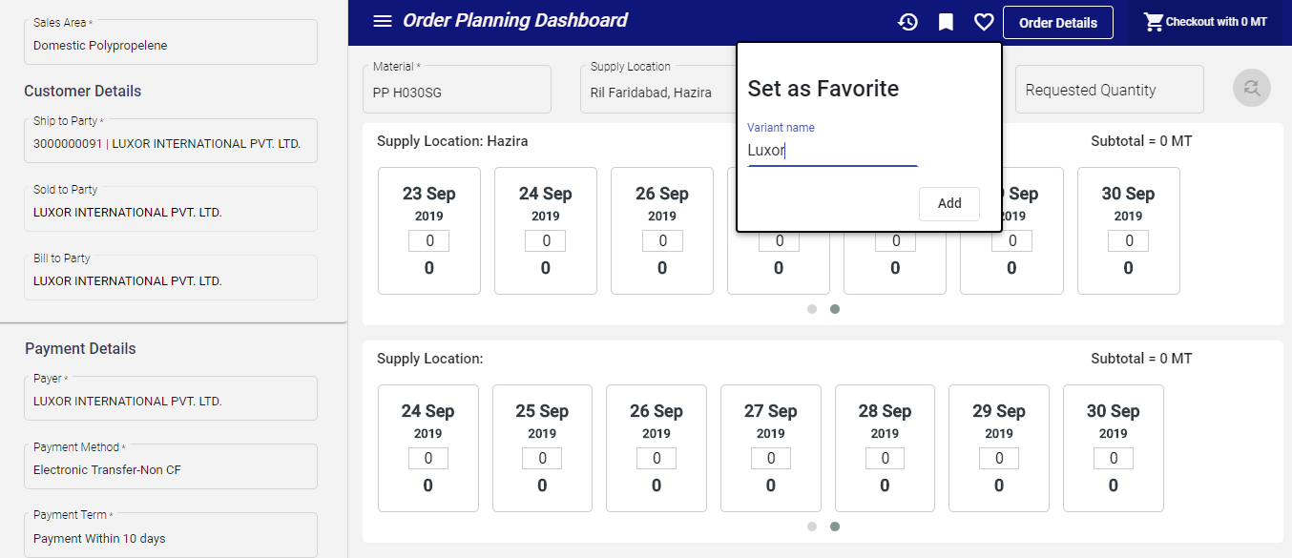

**Step 4: Favorite List Visualization:** It will show all favorites corresponding to the particular agent in which user can delete, load favorites and search based on any fields present in the saved combination. There is a pagination available to see the data present as per the page.

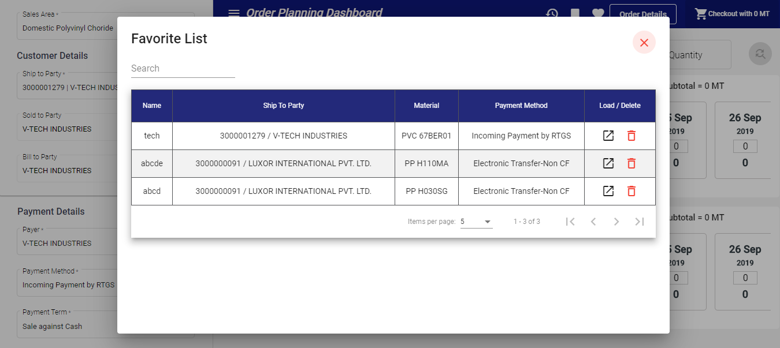

**Step 5: Order Notification View:** It will give a visibility to user to see the crm order number generated from the backend against its referrence number and the combination for which order has been placed. It will also give error message if there would be any issue while generating the crm order number.

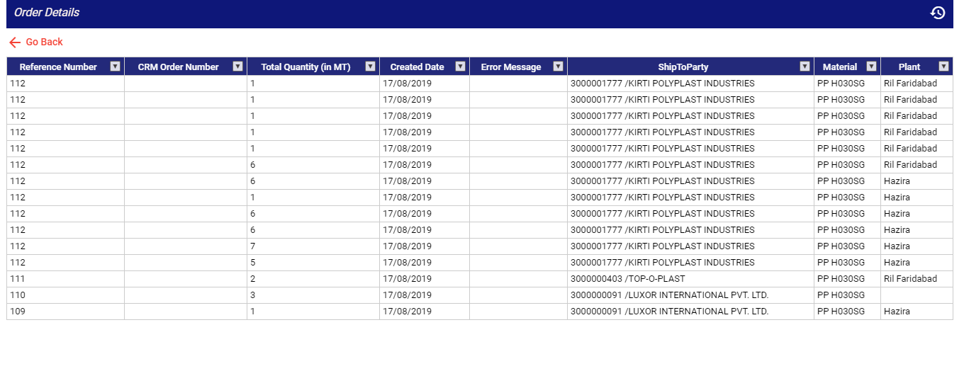

**Step 6: Order Summary View:** Modification of dispatch summary screen with extra fields

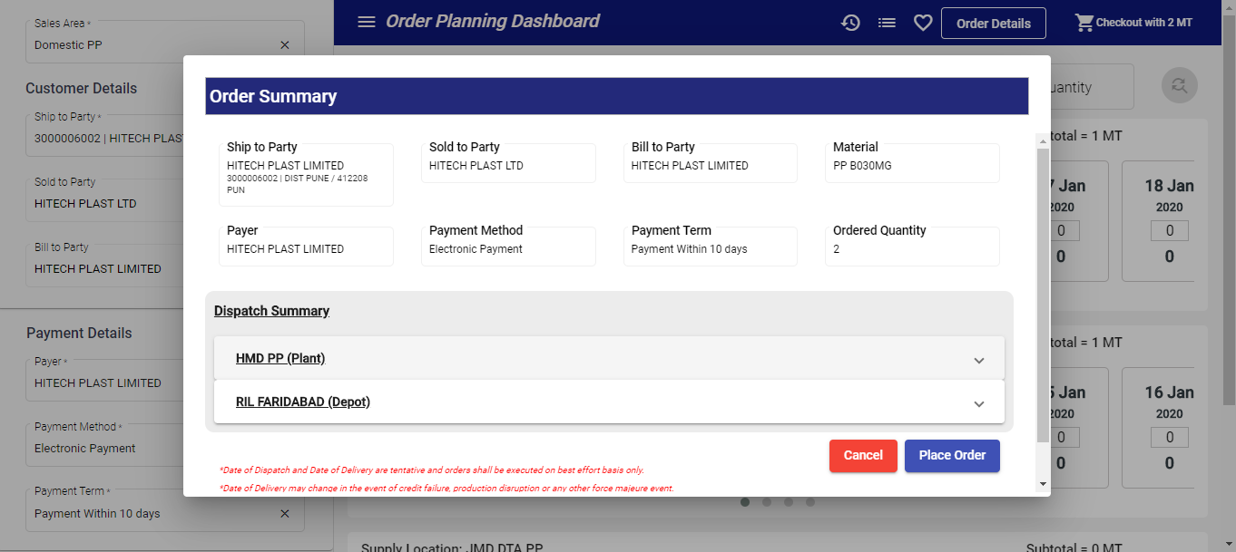

Extra fields are Spl Lot , PO Number , PO Date and Remarks 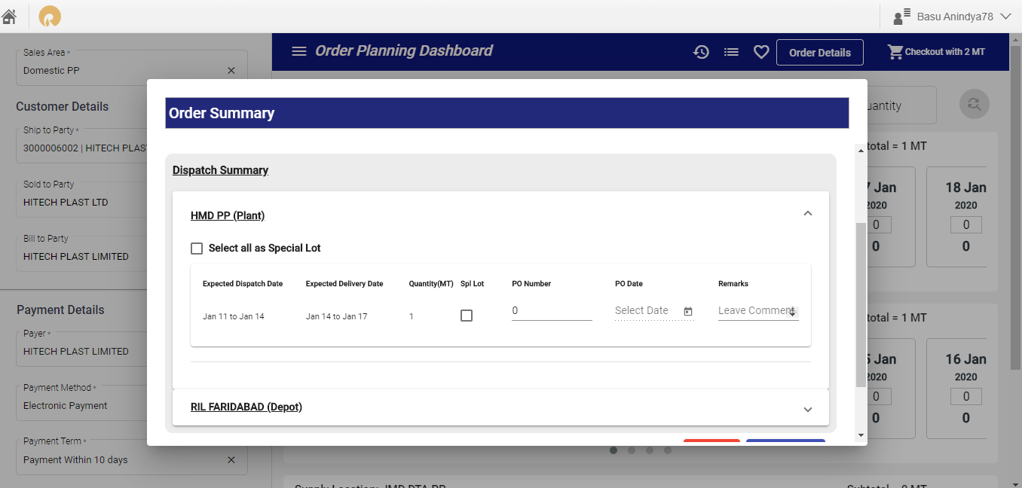

**Step 7:** User has given provision to place order by requesting Special Lot and Storage Location. There are other details needed like PO Number, PO Date and Remarks which ll be manually given by a user.

